# **Zoho Creator Customer Portal**

A Customer Portal in Zoho Creator typically refers to a dedicated space within your application where your customers can interact with your business, access specific information, and perform certain actions. The Customer Portal feature allows you to create a user-friendly interface for your customers to log in, view their data, submit forms, and engage with your business processes.

Here are some key features and functionalities you might find in a Zoho Creator Customer Portal:

**1.User Authentication:**  
 ->Customers can have their login credentials to access the portal securely.  
  
**2.Data Access:** ->Customers can view and interact with data that is relevant to them.  
 ->Customized views and reports can be created to display specific information to each user.  
  
**3.Form Submissions:** ->Customers can submit forms through the portal to provide information or initiate processes.  
  
**4.Workflow Actions:** ->Customers may trigger certain workflows or actions based on their interactions within the portal. **5.Communications:** ->There may be communication features such as messaging or notifications to facilitate interaction between customers and your business.  
  
**6.Access Controls:** ->Admins can set up different access controls to define what data and functionalities are available to different portal users.  
  
**7.Custom Domain:**  
 ->Admin host the customer portal on their own domain instead of the default Zoho Creator domain.

To understand the Zoho Creator Customer Portal in detail with screenshot as below:

1.Login to zoho creator account.

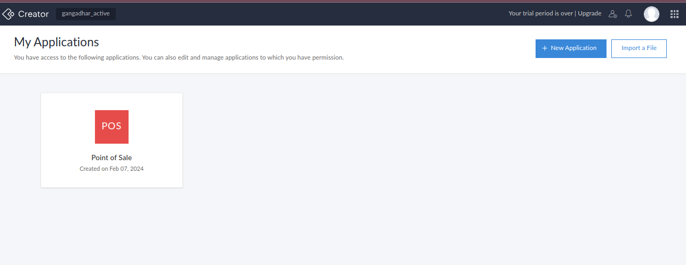  
 2.Navigate to the edit mode of the target application and click Settings on the top of the page.

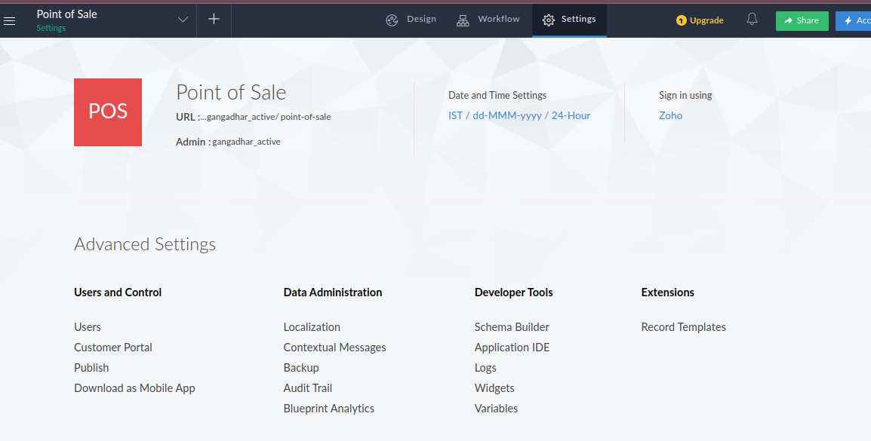

3.Click Customer Portal option under the Users and Control section.

  
4.In the next page click on the “Configure Portal”.

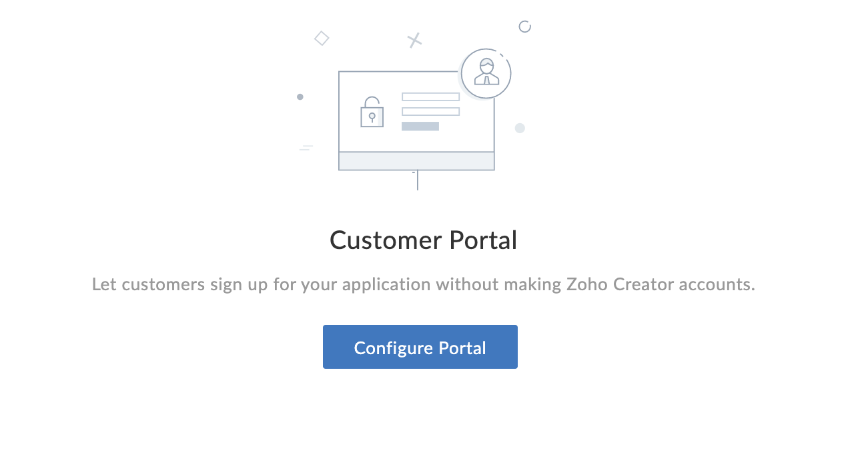

5.The portal url page will appear. In this page you can choose to host the customer portal on Zoho's default domain or on a custom domain.

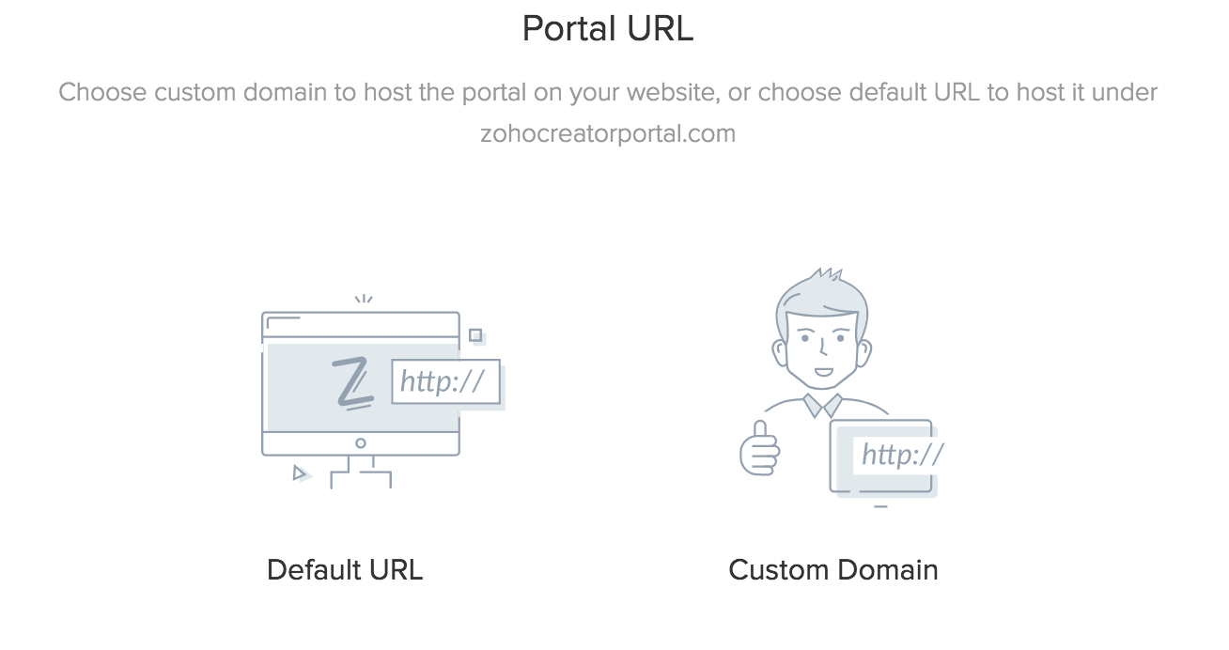  
For custom domain go through link:  
<https://www.zoho.com/creator/newhelp/app-settings/understand-custom-domain.html>  
6.To host the customer portal on default domain. Select the Default URL option in the portal URL page.

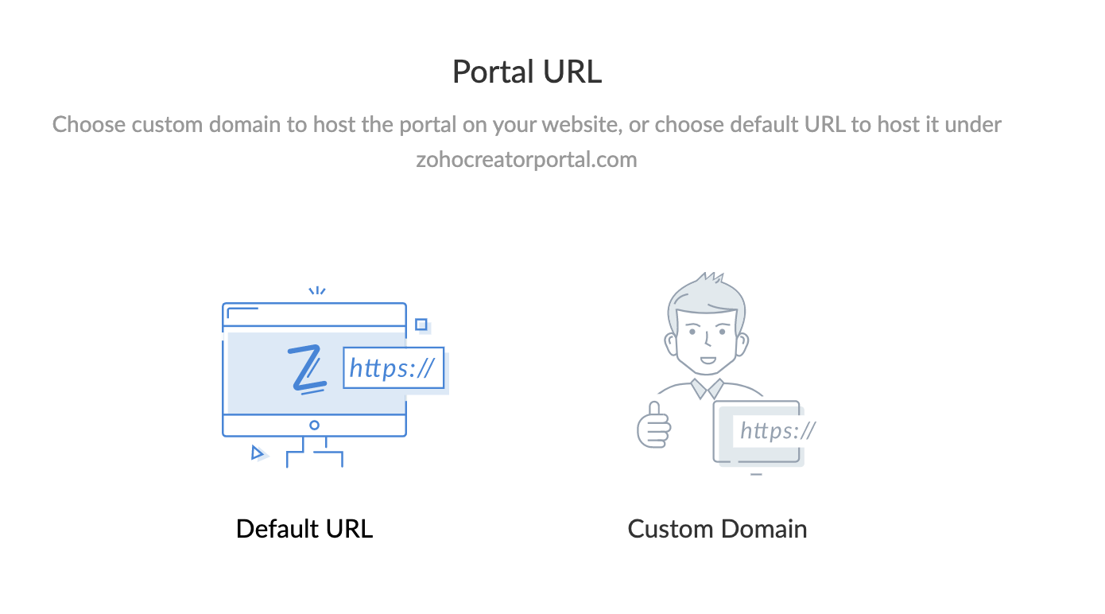  
  
7.The portal types page will appear. In this page, the access type for the customer portal can be selected from the three options available:Public,Private, and Restricted.  
  
**Public-** Any user with the link to the customer portal can sign up and access it.  
**Private-** Only users invited by the admin of the customer portal can access it. Users cannot sign up for the portal on their own.  
**Restricted-** The users have to sign up and get approved by an admin in order to access the portal.

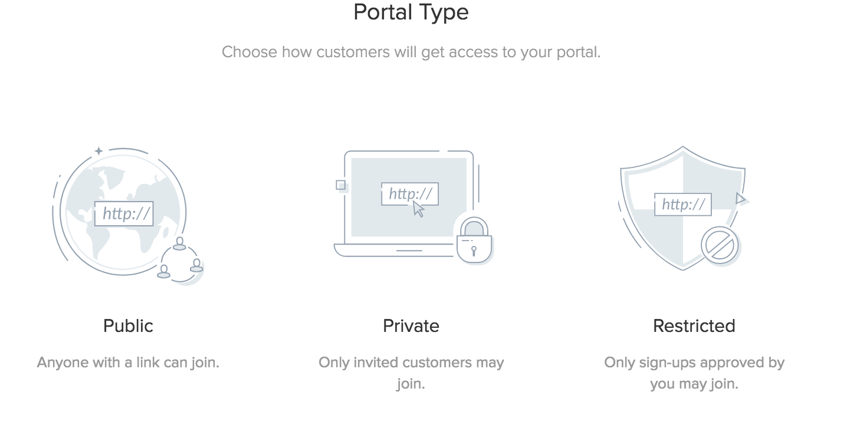  
8.The Portal Permission page will appear. In this page, permission for the user can be selected from the two options available: Customer and Custom.

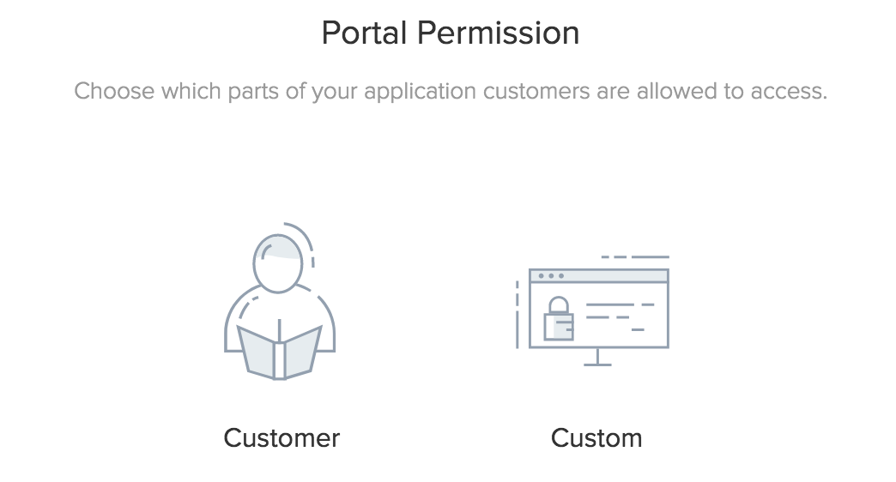

**Customer:**The Customeroption helps you create a customer portal for your users **Custom:**The Customoption helps you create a new customized permission set for the users accessing the customer portal. When the custom option is select, theCustom Permissiontab will appear. Configure the name and permissions and click Add.  
  
9.Enter the permission name and which are forms customer can access.  
Like which form customer can view forms and report or we can give delete record access to customer.

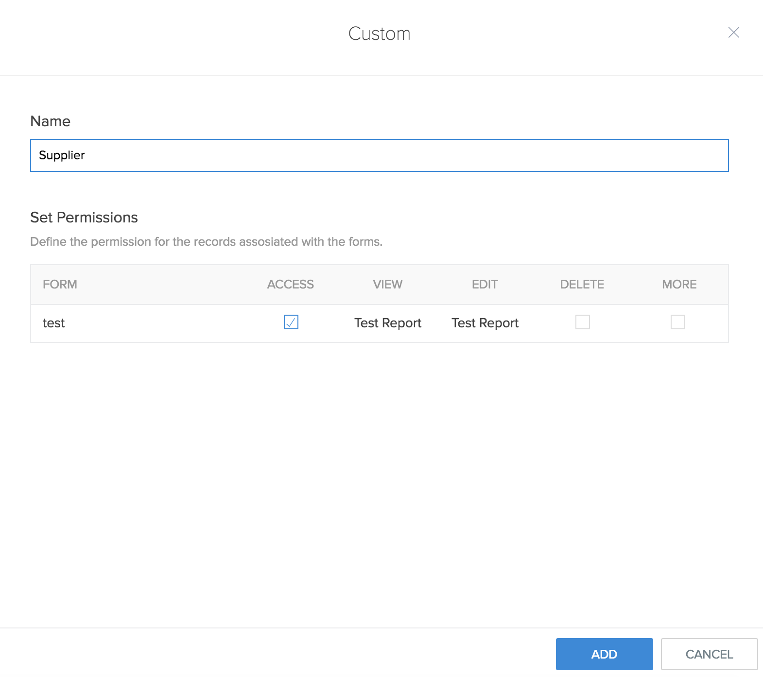

10.The portal will now be set up and the changes will appear in the Customer Portal page.  
  
Admin can add customer to customer portal.

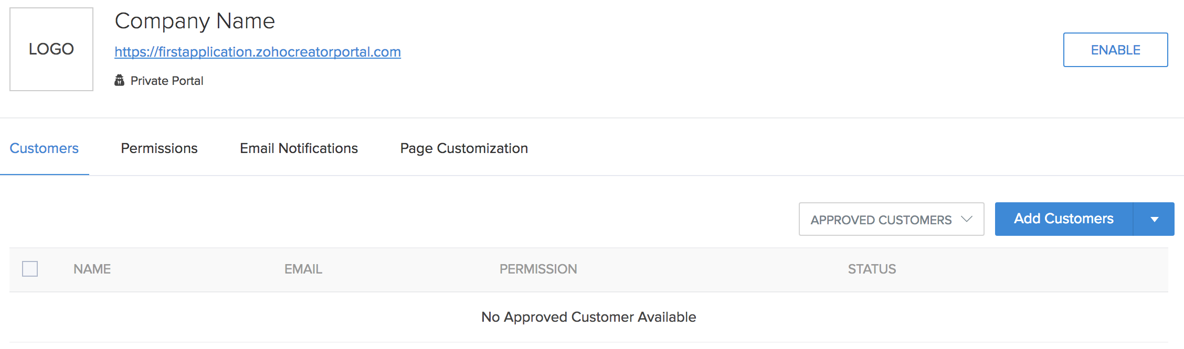  
  
You should refer to the official Zoho Creator documentation, which is regularly updated.   
  
Reference:  
  
https://www.zoho.com/creator/newhelp/app-settings/understand-customer-portal.html